Hello, my lovely students!

Our topic is Health Care and Medicine (Здравоохранение и медицина).

- Learn the words. Watch the video (Выучи слова устно и письменно. Смотри видео по теме – повторяй, запоминай!).

New words:

health care [ˈhelθ.keə] здравоохранение

medicine [ˈmedsn] медицина,лекарство

hospital [ˈhɒspɪtl] больница

doctor [ˈdɒktə] врач

to be ill [ɪl] болеть (используется, когда кто-то

страдает от затяжной болезни)

to be sick [sɪk] болеть (используется, когда кто-либо страдает

краткосрочным заболеванием)

patient [ˈpeɪʃnt] пациент

injection [ɪnˈdʒek.ʃən] укол, инъекция
- Read the rules for good health. Translate into Russian. Remember.

(Прочитай правила хорошего здоровья. Переведи. Запомни.)

RULES FOR GOOD HEALTH

People should follow some rules to stay healthy.
- When you get up air the room.

- Do morning exercises every day.

- Wash to the waist or take a shower.

- Don’t hurry when you have your meal.

- Work and have a rest.

- Eat in time.

- Go to bed in time and rise early.

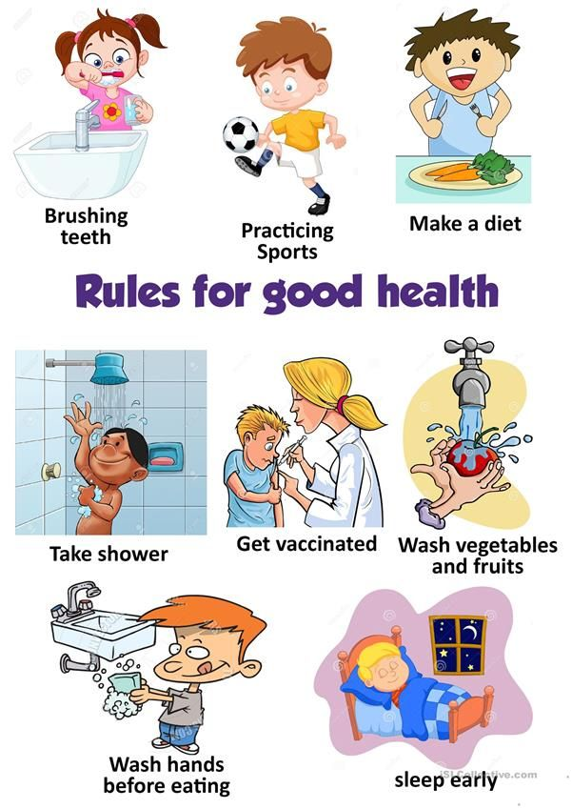

- Write down some more rules for good health (look at the pictures).

(Глядя на картинки, запиши другие правила, которые помогут тебе оставаться здоровым.)

- Read and translate the text.

(Прочитай и переведи текст.)

Hygiene of hands
Wash hands thoroughly with soap and water before and after every meal and after visiting the toilet or being out-of-doors. Soaping and rinsing should cover the areas between fingers, nails and back of the hand. Hands should be dried with a clean towel after wash. The towel at the wash stand has to be washed and changed every day.

If you need to use a handkerchief or tissue, wash your hands after that. Keep your nails short.

- Watch the video and learn the song by heart.

(Посмотри видео и выучи песню наизусть).

- For elder students. Read and translate. Ask as many questions as possible.

Medicines and health
Medicines are not meant to live, an English proverb says. Yes, that's true and we may add that good health is better than the best medicine. If your health is good, you are always in a good mood. You have a sound mind in a solid body, as an old Latin saying goes. The English proverb "Sickness in the body brings sickness to the mind", expresses the similar idea, but from the different point of view. The profession of a doctor is one of the most noble, respected and needed in the world, as we turn to a doctor for advice at the hardest moments of our life, when we fall ill or suffer from pain or some disorder in our body and soul. We complain of low medical treatment, poor equipment of hospitals, difficulties in getting this or that medicine and so on. What a pity we start to value our health only when it is necessary to take medicine. Taking medicine is an unpleasant thing of course, and if we want to avoid it, we should go in for sport and keeps ourselves fit. Physical exercises are necessary. Physically inactive people catch cold more often than those who do plenty of exercises. Physical exercises are good pastime.
Here some rules of good health:
Take long walks in the open air as often as you can.
Keep your body clean.
Keep your teeth clean.
Wear clean clothes.
Sleep with your window open.
When you are reading or writing let the light come from your left shoulder.
Have plenty of fruits and vegetables all the year round: "An apple a day keeps the doctor away.”

